

**GAME DESIGN DOCUMENT**

**Index**

**Game Overview 1**

**Art 3**

**DESIGN 6**

**PROGRAMMING 8**

**MANAGEMENT 9**

**REFERENCES 9**

# Game Overview

**What is the Game About?**

A 3D top-down maze game where the goal is reach an end goal. The player will have obstacles standing in his way, such as static booby traps & enemies that can track and chase the player. The player has to avoid these traps and enemies via precise movement.

**Game Theme**

Medieval.

The game will take place in a catacomb/dungeon.

**Game Genre**

3D Top-down maze game

**Game Platform**

PC

**Game Story**

The player is a solo adventurer exploring the depths of a dungeon for its loot and riches(this might be considered grave robbing)

**Target Audience**

Everyone

# 

# 

# Art

**Characters**

| **N.O** | **Name of Character** | **Type** | **About the Character** | **Abilities** |
| --- | --- | --- | --- | --- |
| **1** | [Sir Dog-eridoo](https://assetstore.unity.com/packages/3d/characters/animals/dog-knight-pbr-polyart-135227) | The player | Dog :)  Incapable of fighting despite appearances | What babies can’t do—walk |
| **2.** | [Skeletons](https://assetstore.unity.com/packages/3d/characters/creatures/low-pol-skeleton-188865) | Enemy | Skeletons that roam the halls of the dungeon, attacking anything it sees. | What the player can’t do—actually fight |

**Environments**

| **N.O** | **Name of Region** | **Levels** | **About the Region** | **Enemies** |
| --- | --- | --- | --- | --- |
| **1** | Tomb of Kirazan | 2 | Catacombs/Dungeon | Skeletons! |

**UI DESIGN**

Discuss the types of UI design and the art style of the UI design that will be used. (Dark Theme, Purple and Black Background, Have the sense of horror that is related to the horror game) Insert 3 different example images from other games for the inspiration for your UI design.

Modernistic & clean font—easy to read.

Simple to match the low-poly art style of the game.

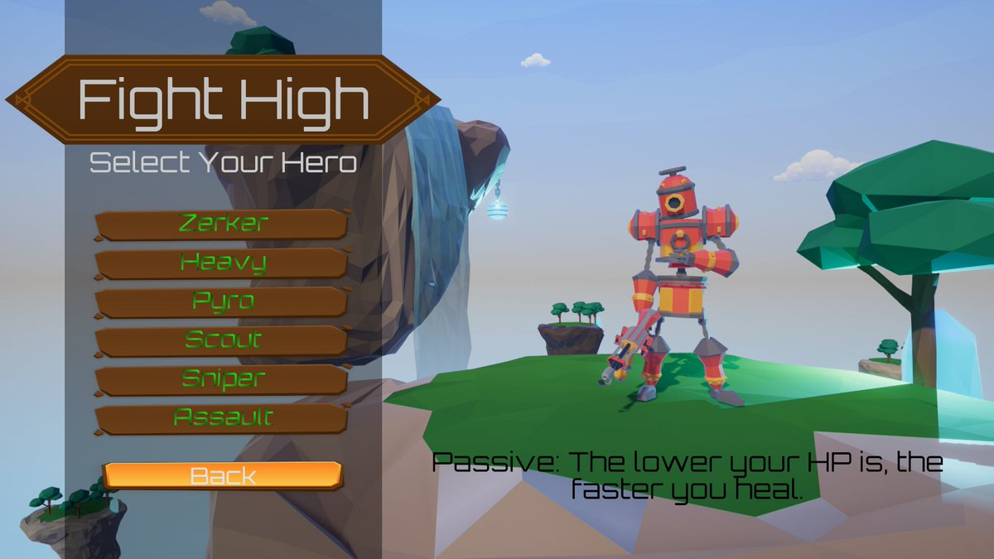

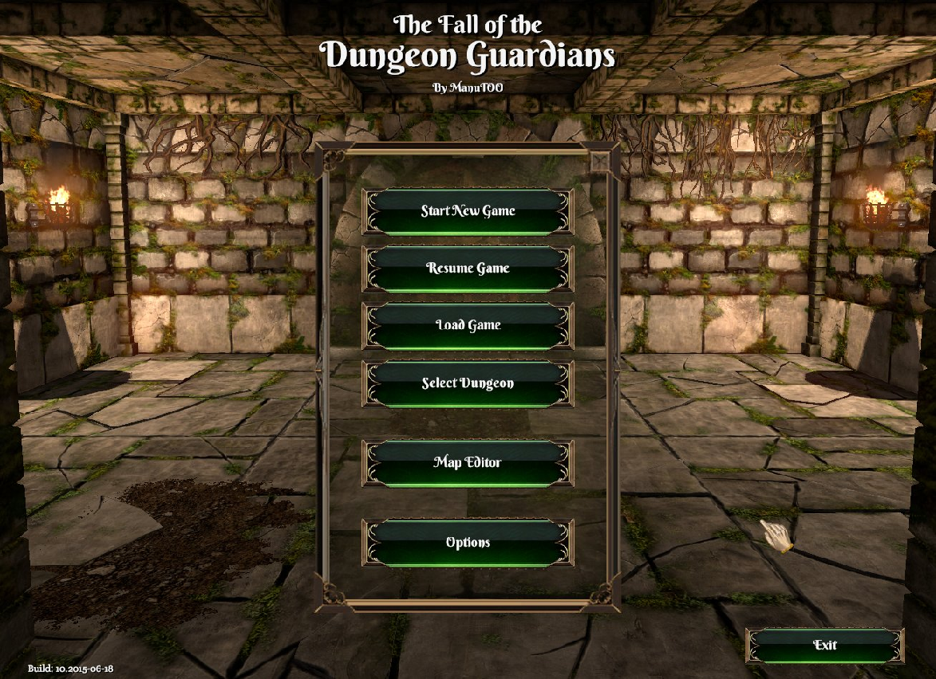

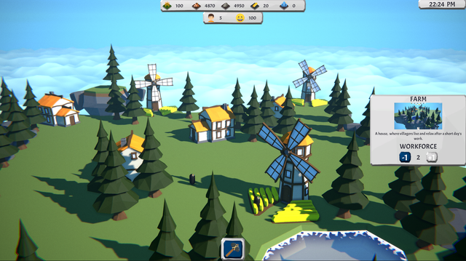

# DESIGN

**LEVEL DESIGN**

| **N.O** | **Region** | **About the Level** | **Objectives of the Level** | **Challenges of the Level** |
| --- | --- | --- | --- | --- |
| **1** | Tomb of Kirazan | Introducing the player to the game’s mechanics | 1. Collect all the treasures 2. Reach the end goal | 1. Lava Puddles 2. Spike Traps 3. Skeletons |
| **2** | Tomb of Kirazan | Developing the ‘maze’ part of the game.  Also tests player on level 1’s introduced obstacles, while introducing a new obstacle. | 1) Collect all the treasures  2) Reach the end goal | 1) Lava Puddles + Spike Traps + Skeleton  2) Moving platforms + Lava Puddles |

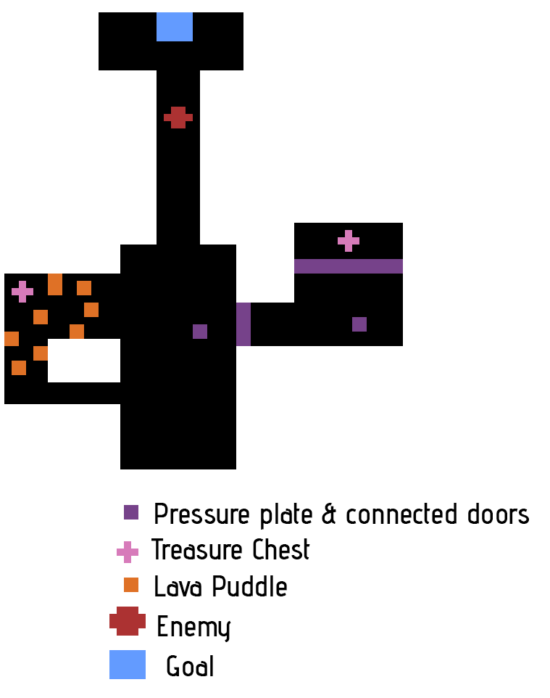

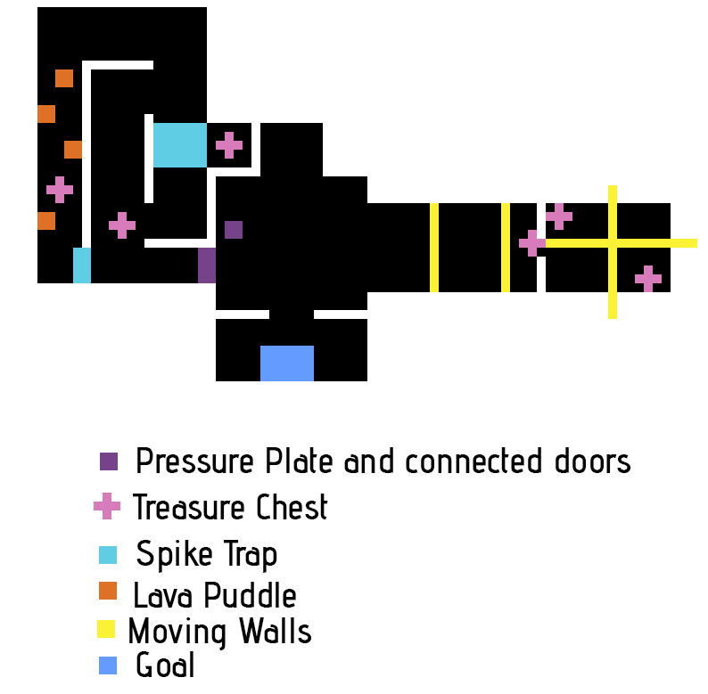

**SOUND DESIGN**

**Background Sound**

Main Menu BGM: [Heartbeat - Royalty Free Fantasy Music](https://www.youtube.com/watch?v=LKEBUbxKz88&list=PLeFG7BiHU9yoBHzDfng862M2N0WOJmYPf&index=9)

Game BGM: [Planning](https://youtu.be/wwcWnS_o3cw)

**Sound Effects**

**Level complete jingle:** [**08687 shine magic stinger**](https://freesound.org/people/Robinhood76/sounds/516854/)

**Level fail jingle: Mixkit - Ominous Drums 227**

**Player taking damage: Mixkit - Small Hit in a Game 2072**

**Player picking up health potion:** [**Health Pickup**](https://pixabay.com/sound-effects/health-pickup-6860/)

**Player picking up a treasure chest: Mixkit - Clinking Coins 1993**

**Not enough points to open door:** [**locked door**](https://freesound.org/people/Leady/sounds/12739/)

# 

# PROGRAMMING

**GAME SYSTEMS**

The player has to explore each level collecting treasure chests. Collecting all of them will unlock a final door leading to the next level.

In his way will be enemies and obstacles that can hurt the player. When the player loses all his HP, the level will fail and you will have to restart the level.

To replenish HP, the player can pick up health potions placed around in the levels.

**GAME MECHANICS**

Discuss the game mechanics to be used for the game. This includes the attack moves, defend moves, combo moves etc of the hero and enemy characters. Also include the triggers such as pick up items (speed pick up, health pick up, weapon pick up) etc. Map out the game controls to the key board and mouse image seen below

The player is only able to move using WASD & the arrow keys.

The enemy is able to chase the player and swing their sword, attacking.

Moving walls that move back and forth to mess with the player’s movement

Spike traps that extends out and in on a timer

Lava puddles that hurt the player on contact

Health potion pick up trigger

Treasure chest pick up trigger

Door interaction trigger

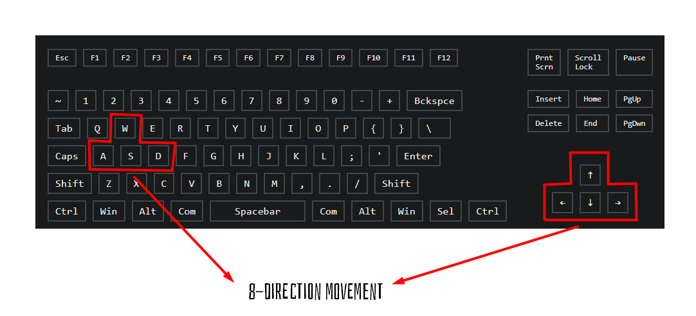

# MANAGEMENT

**SCHEDULE OF GAME PRODUCTION (3 WEEKS)**

| WEEK | Things to be Start On | Things to be Completed |
| --- | --- | --- |
| Week 1 | Conceptualization & level blueprints | NA |
| Week 2 | Level creation in Blender & Unity | Level creation in Blender & Unity  Conceptualization & level blueprints |
| Week 3 | UI Design, audio & beautifying | UI Design, audio & beautifying |

# REFERENCES

[Player character model](https://assetstore.unity.com/packages/3d/characters/animals/dog-knight-pbr-polyart-135227)

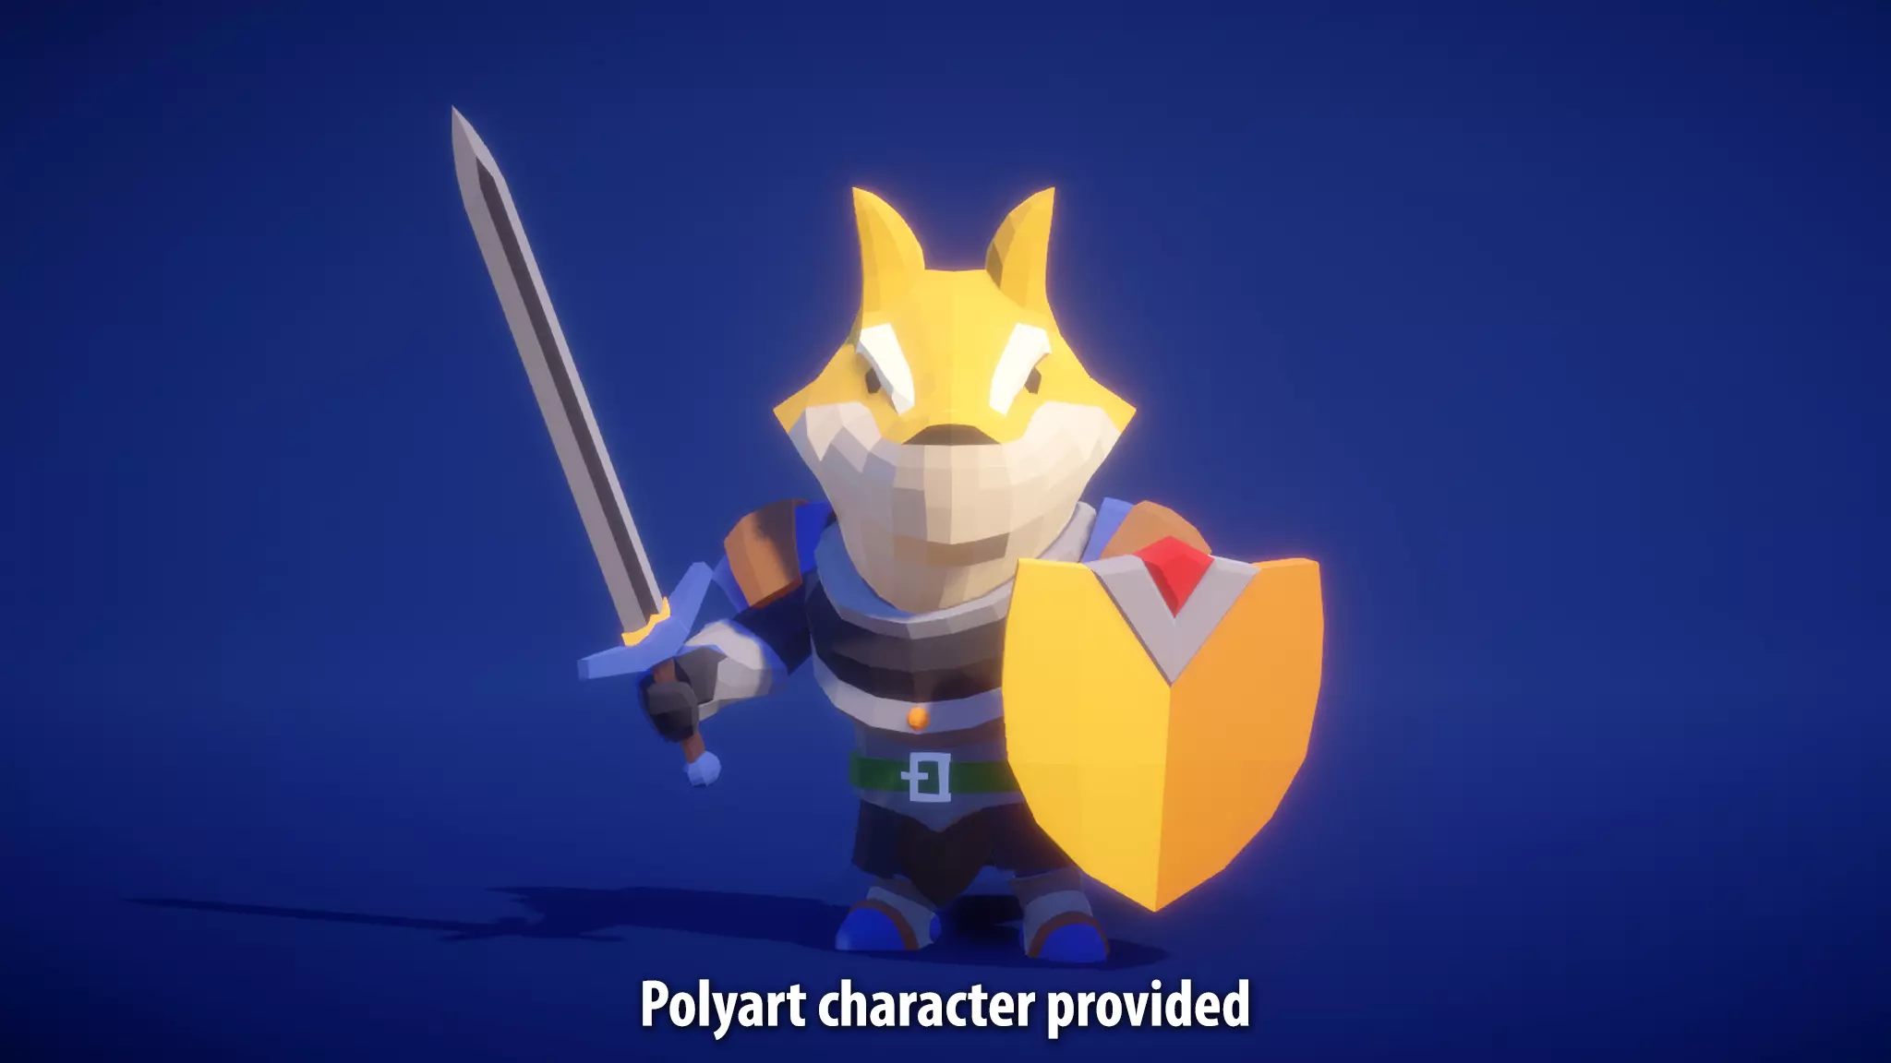

[Enemy skeleton model](https://assetstore.unity.com/packages/3d/characters/creatures/low-pol-skeleton-188865)

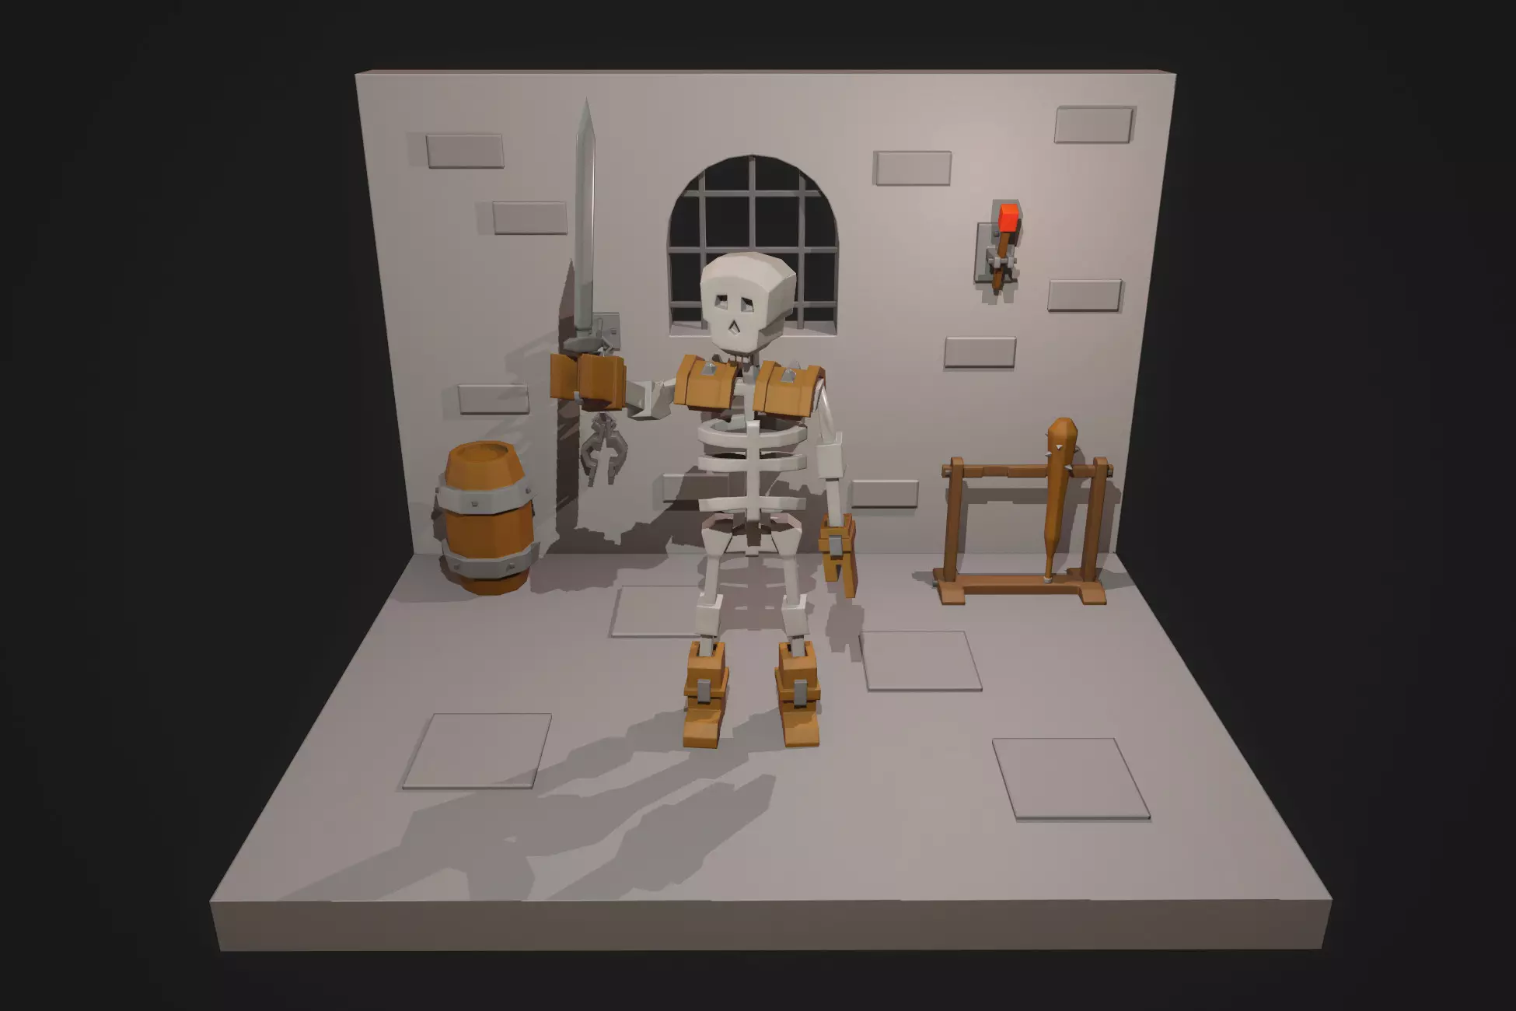

[Health Potions](https://assetstore.unity.com/packages/3d/props/low-poly-magical-potions-pack-227572)

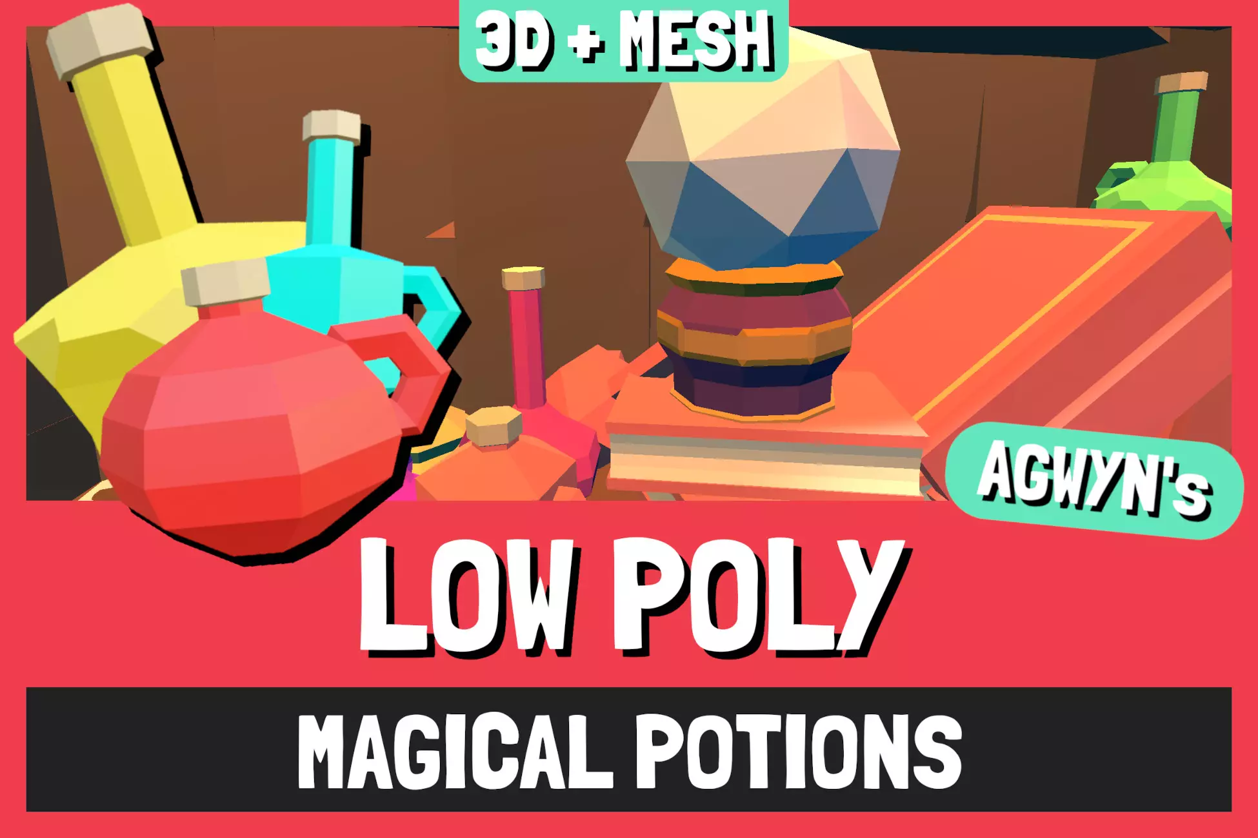

[Torch particles](https://assetstore.unity.com/packages/vfx/particles/fire-explosions/low-poly-fire-244190)

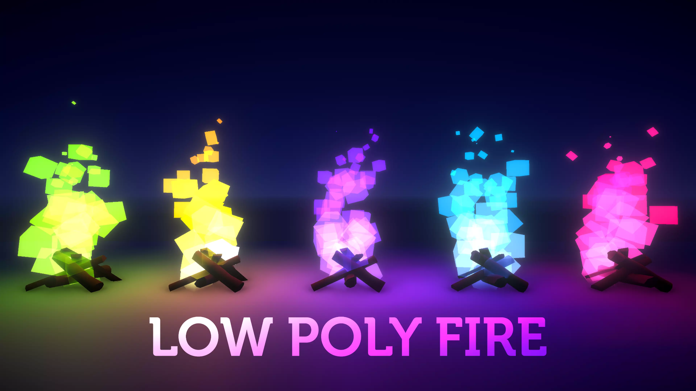

[Level Decor](https://assetstore.unity.com/packages/3d/environments/dungeons/low-poly-dungeon-lite-fantasy-modular-kit-224313)

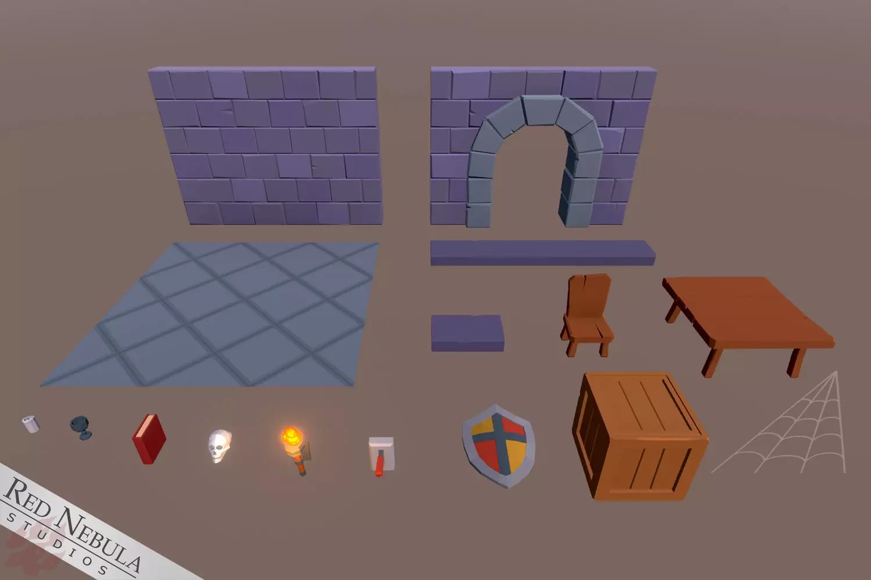

[Level Decor 2](https://assetstore.unity.com/packages/3d/environments/dungeons/low-poly-free-dungeon-pack-191979)

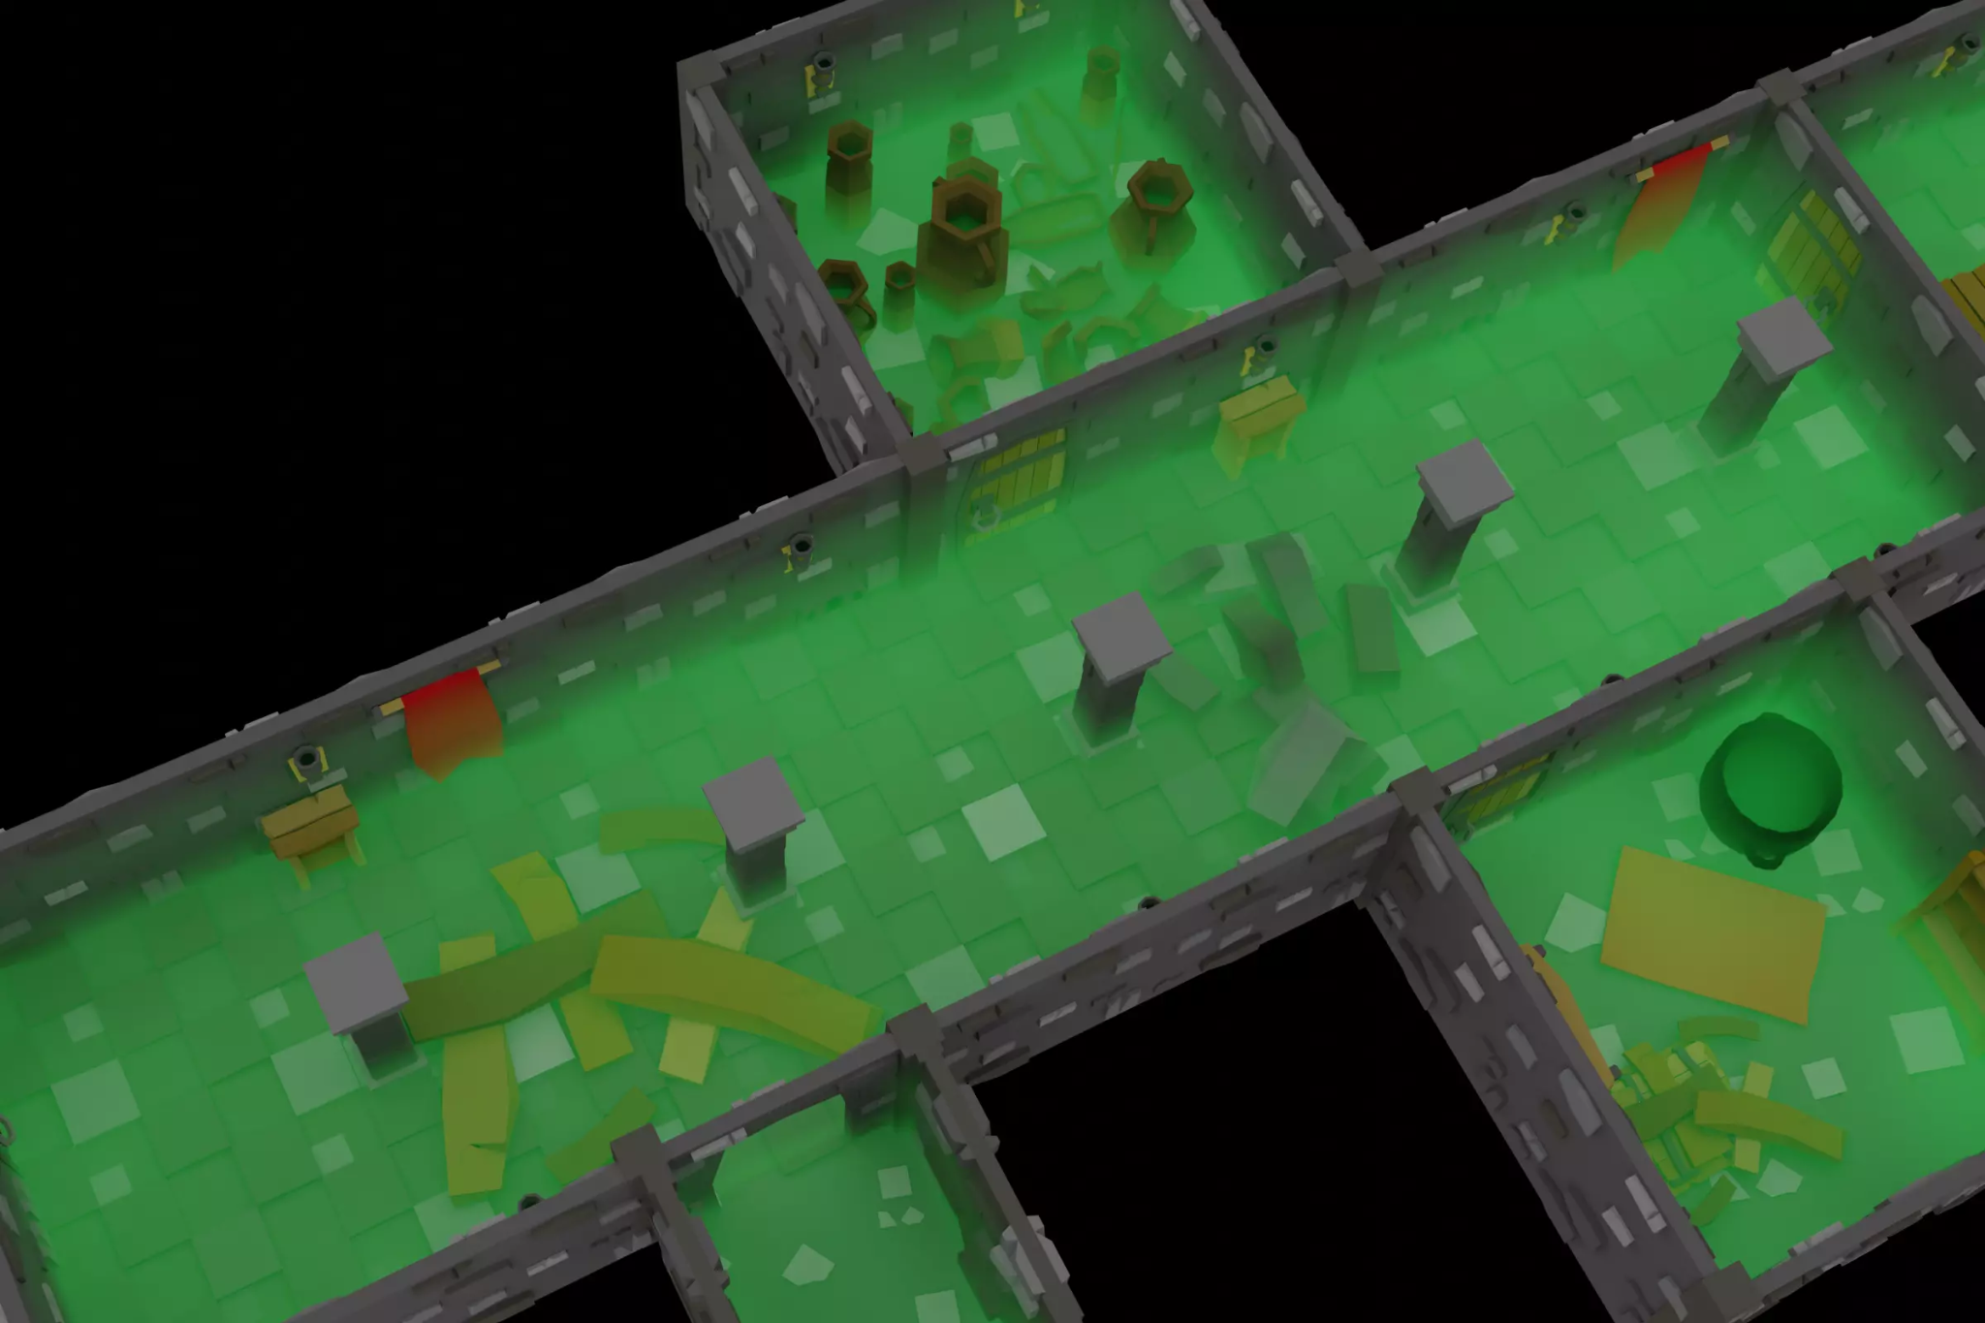

Main Menu BGM: [Heartbeat - Royalty Free Fantasy Music](https://www.youtube.com/watch?v=LKEBUbxKz88&list=PLeFG7BiHU9yoBHzDfng862M2N0WOJmYPf&index=9)

Game BGM: [Planning](https://youtu.be/wwcWnS_o3cw)

[Mixkit](https://mixkit.co/)

Level fail jingle: Mixkit - Ominous Drums 227

Player taking damage: Mixkit - Small Hit in a Game 2072

Player picking up a treasure chest: Mixkit - Clinking Coins 1993

Player picking up health potion: [Pixabay - Health Pickup](https://pixabay.com/sound-effects/health-pickup-6860/)

Level complete jingle: [08687 shine magic stinger](https://freesound.org/people/Robinhood76/sounds/516854/)

Not enough points to open door: [locked door](https://freesound.org/people/Leady/sounds/12739/)

Fonts:

[Bebas Neue](https://fonts.google.com/specimen/Bebas+Neue)

[Bahiana](https://fonts.google.com/specimen/Bahiana)